**WEB TECHNOLOGY**

**TITLE-** **FOOD ORDERING SYSTEM**

**GROUP MEMBERS:**

HIMANSHU AGARWAL- **18BIT0118**

KAPIL POONIA- **18BIT0096**

**Abstract-** This website will replace the Menu card used in restaurants with this digital way of ordering the food. Each customer’s table will have the device in which we have this website logged in. If the customer is coming for the first time, he has to log in using the name with which he/she wants the bill.

This will reduce the restaurants expenditure on waiters who used to take order from customer. Moreover customers cannot complain for the order they made because the restaurant manager will have the data of the items ordered by the customer.

**Web Technologies Used-** HTML, CSS, JAVASCRIPT, JQUERY

**MODULE DESCRIPTION:**

**HTML:**

Hypertext Markup Language (HTML) is the standard markup

language for making site pages and web applications. With

Cascading Style Sheets (CSS) and JavaScript, it frames a group

of three of foundation advancements for the World Wide

Web. Internet browsers get HTML records from a web server

or from neighborhood stockpiling and render the reports into

mixed media pages. HTML depicts the structure of a page

semantically and initially included signs for the presence of

the record.

**CSS:**

Cascading Style Sheets (CSS) is a template language utilized

for portraying the introduction of a report written in a

markup language like HTML. CSS is a foundation innovation

of the World Wide Web, close by HTML and JavaScript.

CSS is intended to empower the partition of introduction and

substance, including design, hues, and textual styles.

**JavaScript:**

JavaScript, regularly abridged as JS, is an abnormal state,

translated programming language that adjusts to the

ECMAScript determination. It is a programming language that

is portrayed as powerful, pitifully composed, model based

and multi-worldview.

Nearby HTML and CSS, JavaScript is one of the center

advancements of the World Wide Web. JavaScript empowers

intelligent website pages and is a fundamental piece of web

applications. By far most of sites use it, and real internet

browsers have a devoted JavaScript motor to execute it.

**jQuery:**

jQuery is a JavaScript library intended to streamline HTML

DOM tree traversal and control, just as occasion taking care

of, CSS movement, and Ajax. It is free, open-source

programming utilizing the lenient MIT License. Web

examination (from 2017) shows that it is the most generally

conveyed JavaScript library by an enormous edge.

jQuery's language structure is intended to make it simpler to

explore a record, select DOM components, make activitys,

handle occasions, and create Ajax applications. jQuery

additionally gives capacities to designers to make modules

over the JavaScript library.

**OUTLINE OF THE PROJECT:**

ENTERING RESTAURANT AND HANDLING DEVICE TO ORDER FOOD

EDIT PROFILE

CHECK ORDER STATUS

ORDER FOOD

CUSTOMERS

ORDERS

LOGIN

SIGNUP

admin

FOOD MENU

customer

**FRONTEND**

**LOGIN PAGE:**

**Login.html**

<html>

<head>

<title>Online Food Ordering System</title>

<style type="text/css">

html

{

background-color:red;

}

body

{

margin-top:120px;

margin-left:600px;

background-color:white;

width:25%;

height:70%;

}

td.t1

{

color:red;

}

h1.hd1

{

color:red;

background-color:blue;

text-align:center;

}

h3.hd2

{

color:green;

}

</style>

</head>

<body>

<h1 class="hd1">Online Food Delivery</h1>

<table align="center">

<tr>

<td colspan="2"><h3 class="hd2">Login for food ordering system</h3></td>

</tr>

<tr>

<td><h4>Username</h4></td>

<td><input type="text" name="username">

</td>

</tr>

<tr></tr>

<tr>

<td><h4>Password</h4></td>

<td><input type="password" name="Password"></td>

</tr>

<tr></tr>

<tr></tr>

<tr>

<td colspan="4" bgcolor="red" align="center"><input type="submit" name="Login"></td>

</tr>

<tr></tr>

<tr></tr>

<tr></tr>

<tr>

<td><h3>New User?</h3></td>

<td><a href="signup.html" target="_parent"><h3>Sign Up</h3></td>

</tr>

</table>

</body>

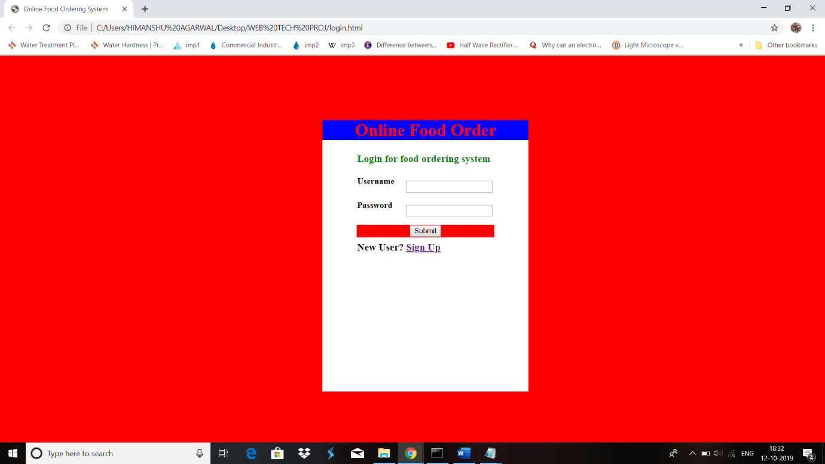</html>

**Sigup.html**

<html>

<head>

<title>Online Food Ordering System</title>

<script src="registration.js"></script>

<style type="text/css">

html

{

background-color:red;

}

body

{

margin-top:120px;

margin-left:600px;

background-color:white;

width:25%;

height:70%;

}

td.t1

{

color:red;

}

h1.hd1

{

color:red;

background-color:blue;

text-align:center;

}

h3.hd2

{

color:green;

}

</style>

</head>

<body>

<form name="registration" action="" onSubmit="return validation();">

<h1 class="hd1">Online Food Order</h1>

<table align="center">

<tr>

<td colspan="2"><h3 class="hd2">Sign Up for food ordering system</h3></td>

</tr>

<tr>

<td><label for="uname"><h4>Username</h4></label></td>

<td><input type="text" id="uname" name="uname">

</td>

</tr>

<tr></tr>

<tr>

<td><label for="name"><h4>Name</h4></label></td>

<td><input type="text" id="name" name="name"></td>

</tr>

<tr></tr>

<tr>

<td><label for="pass"><h4>Password</h4></label></td>

<td><input type="password" id="pass" name="pass"></td>

</tr>

<tr></tr>

<tr>

<td><label for="phone"><h4>Phone Number</h4></label></td>

<td><input type="number" id="phone" name="phone"></td>

</tr>

<tr>

<td colspan="4" bgcolor="red" align="center"><input type="submit" name="Sign Up"></td>

</tr>

<tr></tr>

<tr></tr>

<tr></tr>

<tr>

<td colspan="2"><h3>Already have an account?</h3></td>

<td><a href="login.html" target="_parent"><h3>Login</h3></td>

</tr>

</table>

</form>

</body>

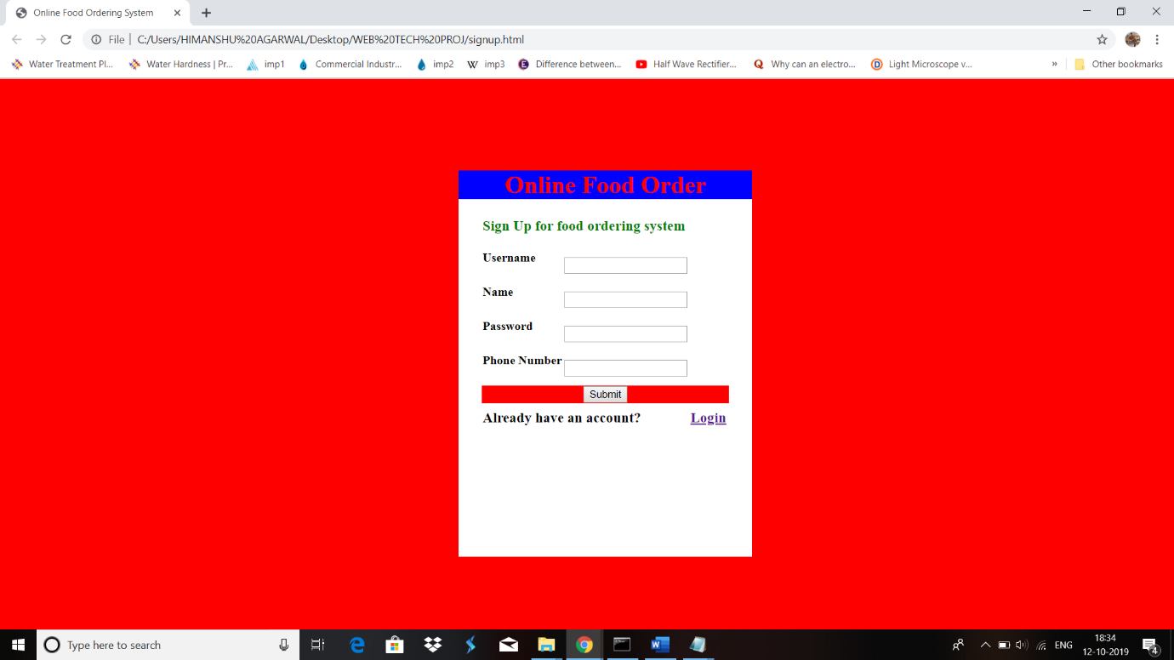</html>

**For Customer**

**Front page:**

**Customer.html**

<!DOCTYPE html>

<html>

<head>

</head>

<frameset rows="22%,*">

<frame src="heading_cust.html" noresize>

<frame src="orderfood.html" noresize>

</frame>

</frame>

</frameset>

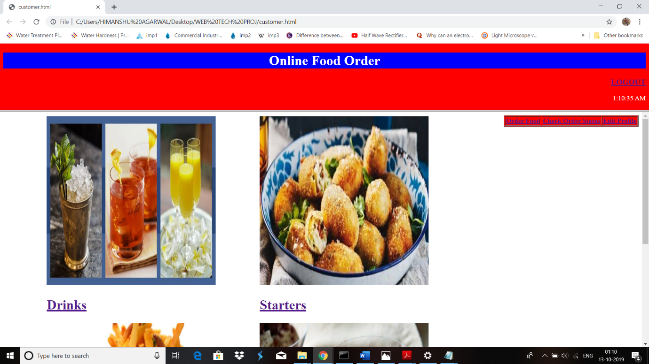</html>

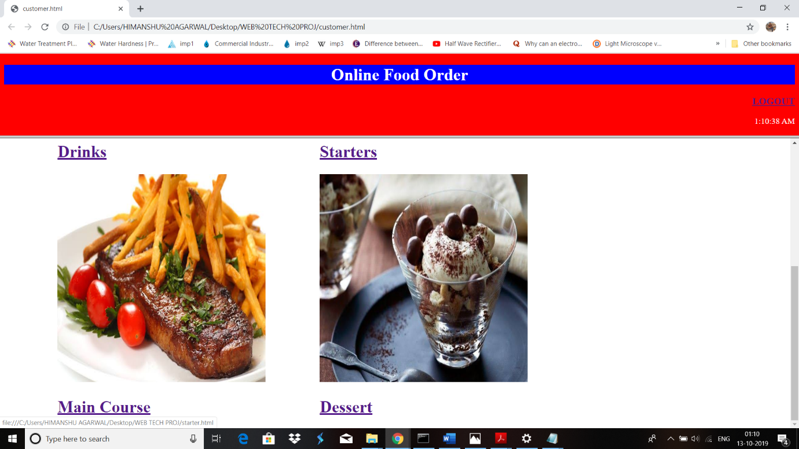

**Heading_cust.html**

<!DOCTYPE html>

<html>

<head>

<style type="text/css">

body

{

background-color: red;

}

h1.hd1

{

color:white;

text-align:center;

background-color:blue;

}

#demo

{

text-align:right;

color:white;

}

</style>

<script type="text/javascript">

var myVar=setInterval(function(){myTimer()},1000);

function myTimer(){

var d=new Date();

var t=d.toLocaleTimeString();

document.getElementById("demo").innerHTML=t;

}

</script>

</head>

<body>

<h1 class="hd1">Online Food Order</h1>

<h3 align="right"><a href="login.html" target="_parent">LOGOUT</a></h3>

<p id="demo"></p>

</body>

</html>

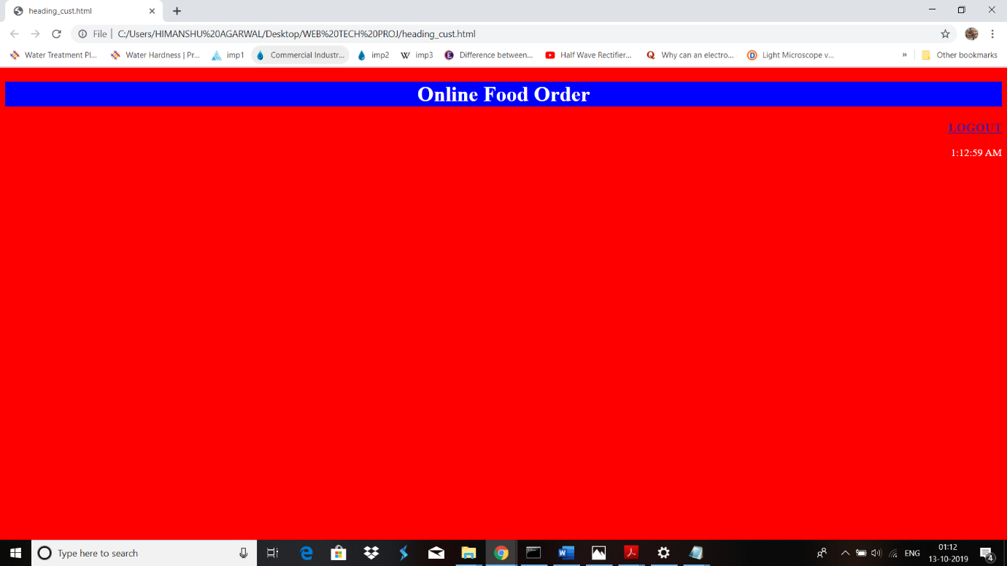

**ORDER FOOD**

**Orderfood.html**

<!DOCTYPE html>

<html>

<head>

<style type="text/css">

body

{

background-color:white;

}

img

{

padding-left:100px;

height:400px;

width:400px;

}

h1{

padding-left:100px;

}

</style>

</head>

<body>

<table align="right" border="1" bgcolor="red">

<tr>

<td><a href="orderfood.html"><b>Order Food</b></a></td>

<td><a href="orderstatus.html"><b>Check Order Status</b></a></td>

<td><a href="editprofile.html" target="_self"><b>Edit Profile</b></a></td>

</tr>

</table>

<table border="0" align="left">

<tr>

<td><img src="drinks.jpg" ></td>

<td><img src="starters.jpg" ></td>

</tr>

<tr>

<td><a href="drinks.html"><h1>Drinks</h1></td>

<td><a href="starter.html"><h1>Starters</h1></td>

</tr>

<tr>

<td><img src="maincourse.jpg"></td>

<td><img src="dessert.jpg"></td>

</tr>

<tr>

<td><a href="maincourse.html"><h1>Main Course</h1></td>

<td><a href="dessert.html"><h1>Dessert</h1></td>

</tr>

</table>

</body>

</html>

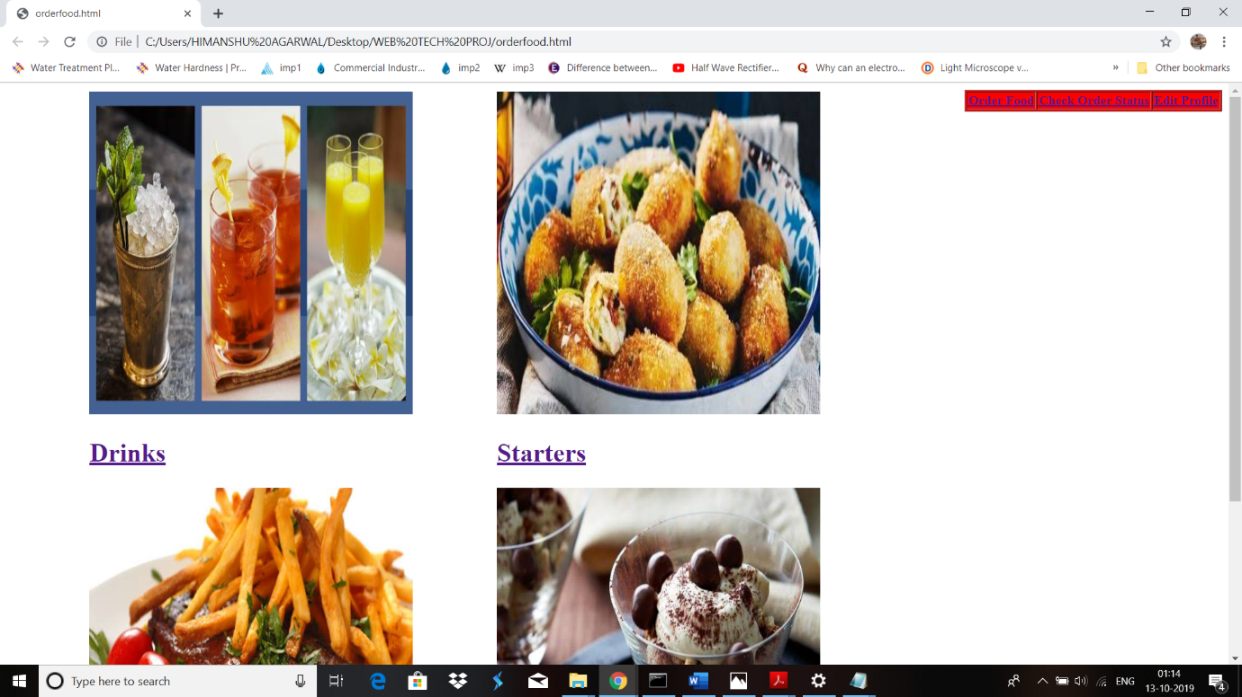

To edit profile:

**Editprofile.html**

|  |  |
| --- | --- |
|  | <!DOCTYPE html> |
|  | <html> |
|  | <head> |
|  | <style type="text/css"> |
|  | body |
|  | { |
|  | background-image: url("deliver.jpg"); |
|  | } |
|  |  |
|  | </style> |
|  | <script src="registration.js"></script> |
|  | </head> |
|  | <body> |
|  | <form name="registration" action="" onSubmit="return validation();"> |
|  |  |
|  | <table align="right" border="1" bgcolor="red"> |
|  | <tr> |
|  | <td><a href="orderfood.html"><b>Order Food</b></a></td> |
|  | <td><a href="orderstatus.html"><b>Check Order Status</b></a></td> |
|  | <td><a href="editprofile.html" target="_self"><b>Edit Profile</b></a></td> |
|  | </tr> |
|  |  |
|  | </table> |
|  | <table align="center" style="padding-left:300px;"> |
|  |  |
|  | <tr> |
|  | <td><label for="uname"><h4>Username</h4></label></td> |
|  | <td><input type="text" id="uname" name="uname"> |
|  | </td> |
|  | </tr> |
|  |  |
|  | <tr></tr> |
|  |  |
|  | <tr> |
|  | <td><label for="name"><h4>Name</h4></label></td> |
|  | <td><input type="text" id="name" name="name"></td> |
|  | </tr> |
|  |  |
|  | <tr></tr> |
|  |  |
|  | <tr> |
|  | <td><label for="pass"><h4>Password</h4></label></td> |
|  | <td><input type="password" id="pass" name="pass"></td> |
|  | </tr> |
|  |  |
|  | <tr></tr> |
|  |  |
|  | <tr> |
|  | <td><label for="phone"><h4>Phone Number</h4></label></td> |
|  | <td><input type="number" id="phone" name="phone"></td> |
|  | </tr> |
|  |  |
|  | <tr> |
|  | <td colspan="4" bgcolor="red" align="center"><input type="submit" name="Edit"></td> |
|  | </tr> |
|  |  |
|  | </table> |
|  | </form> |
|  | </body> |
|  | </html> |

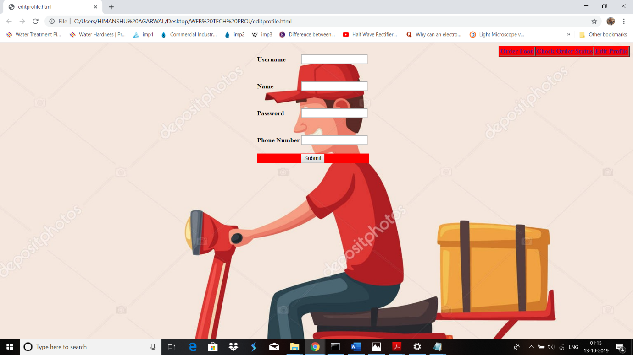

**For Signup and Edit Profile we have performed validation using JavaScript:**

**Registration.js**

function validation()

{

var passid=document.getElementById("pass");

var sphone=document.getElementById("phone");

if(valid_pass(passid,7,12))

{

if(valid_phone(sphone))

{

return true;

}

}

return false;

}

function valid_pass(passid,mx,my)

{

var passid_len = passid.value.length;

if (passid_len == 0 ||passid_len >= my || passid_len < mx)

{

alert("Password should not be empty / length be between "+mx+" to "+my);

passid.focus();

return false;

}

return true;

}

function valid_phone(sphone)

{

var sp_len = sphone.value.length;

if (sp_len == 0 ||sp_len >10 ||sp_len<10)

{

alert("Phone Number should not be empty / length should not exceed or be less than 10");

sphone.focus();

return false;

}

return true;

}

**For different links defined in OrderFood frame:**

**Drinks.html**

|  |  |
| --- | --- |
|  | <html> |
|  | <head> |
|  | <style> |
|  | img{ |
|  | height:200px; |
|  | width:200px; |
|  | } |
|  | </style> |
|  | <title>Drinks</title> |
|  | </head> |
|  |  |
|  | <body> |
|  |  |
|  | <table border=0 align="center"> |
|  | <tr> |
|  | <td><img src="drink1.jpg" id="drink1" ></td> |
|  | <td><img src="drink2.jpg" id="drink2" ></td> |
|  | <td><img src="drink3.jpg" id="drink3" ></td> |
|  | <td><img src="drink4.jpg" id="drink4" ></td> |
|  | </tr> |
|  | <tr> |
|  | <td><h3>Belini</h3></td> |
|  | <td><h3>Lemonade</h3></td> |
|  | <td><h3>Daiquiri</h3></td> |
|  | <td><h3>Mojito</h3></td> |
|  | </table> |
|  | <table align="center" border=0> |
|  | <tr> |
|  | <td><h3>Belini</h3></td> |
|  | <td><h4>Rs.250<h4></td> |
|  | <td> |
|  | <select id="quantity1"> |
|  | <option>QTY</option> |
|  | <option>1</option> |
|  | <option>2</option> |
|  | <option>3</option> |
|  | <option>4</option> |
|  | <option>5</option> |
|  | </select> |
|  | </td> |
|  | </tr> |
|  | <tr> |
|  | <td><h3>Lemonade</h3></td> |
|  | <td><h4>Rs.220<h4></td> |
|  | <td> |
|  | <select id="quantity2"> |
|  | <option>QTY</option> |
|  | <option>1</option> |
|  | <option>2</option> |
|  | <option>3</option> |
|  | <option>4</option> |
|  | <option>5</option> |
|  | </select> |
|  | </td> |
|  | </tr> |
|  | <tr> |
|  | <td><h3>Daiquiri</h3></td> |
|  | <td><h4>Rs.170<h4></td> |
|  | <td> |
|  | <select id="quantity3"> |
|  | <option>QTY</option> |
|  | <option>1</option> |
|  | <option>2</option> |
|  | <option>3</option> |
|  | <option>4</option> |
|  | <option>5</option> |
|  | </select> |
|  | </td> |
|  | </tr> |
|  | <tr> |
|  | <td><h3>Mojito</h3></td> |
|  | <td><h4>Rs.150<h4></td> |
|  | <td> |
|  | <select id="quantity4"> |
|  | <option>QTY</option> |
|  | <option>1</option> |
|  | <option>2</option> |
|  | <option>3</option> |
|  | <option>4</option> |
|  | <option>5</option> |
|  | </select> |
|  | </td> |
|  | </tr> |
|  | <tr> |
|  | <td><input type="submit" id="submit" value="Order"></td> |
|  | </tr> |
|  | <tr> |
|  | <td><a href="orderfood.html">To order other Items,Press this</a></td> |
|  | </tr> |
|  | </table> |
|  | </body> |
|  | </html> |

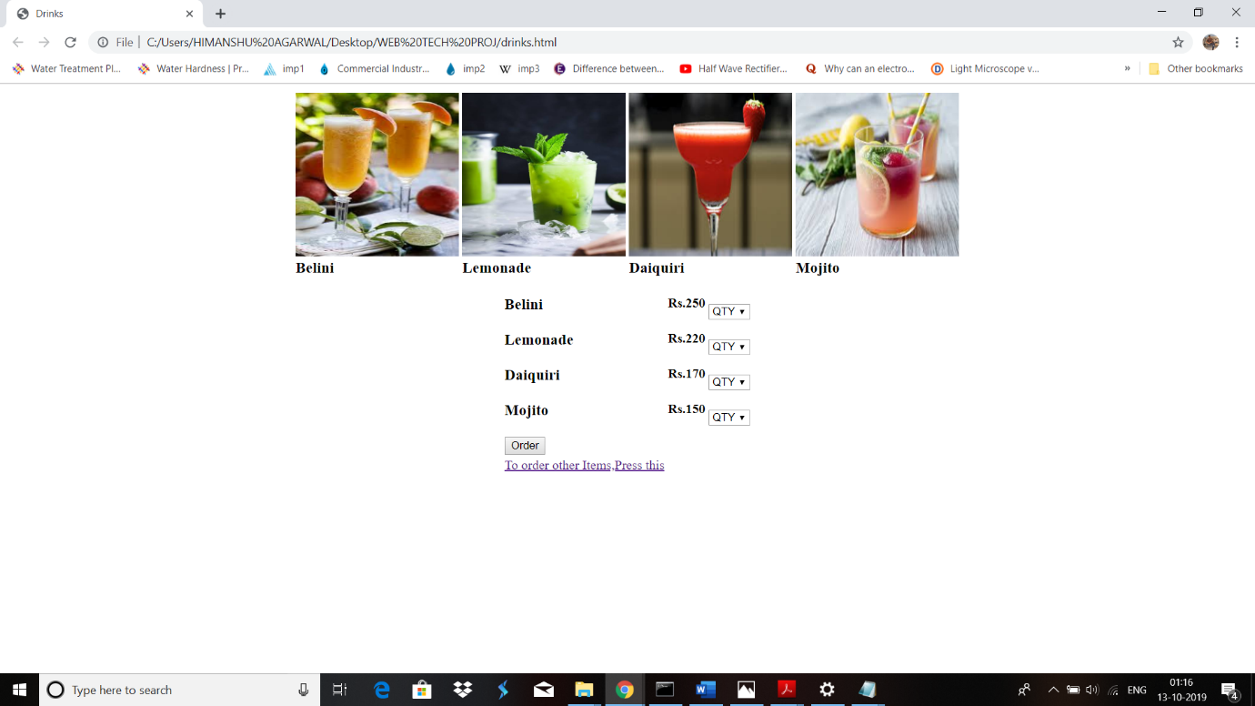

**Starter.html**

|  |  |
| --- | --- |
|  | <html> |
|  | <head> |
|  | <title>Starters</title> |
|  | </head> |
|  |  |
|  | <body> |
|  |  |
|  | <table border=0 align="center"> |
|  | <tr> |
|  | <td><img src="st1.jpg" id="starter1" height="200px" width="200px"></td> |
|  | <td><img src="st2.jpg" id="starter2" height="200px" width="200px"></td> |
|  | <td><img src="st3.jpg" id="starter3" height="200px" width="200px"></td> |
|  | <td><img src="st4.jpg" id="starter4" height="200px" width="200px"></td> |
|  | </tr> |
|  | <tr> |
|  | <td><h3>BabyCorn</h3></td> |
|  | <td><h3>American Corn</h3></td> |
|  | <td><h3>Paneer Chilli</h3></td> |
|  | <td><h3>Spring Roll</h3></td> |
|  | </table> |
|  | <table align="center" border=0> |
|  | <tr> |
|  | <td><h3>BabyCorn</h3></td> |
|  | <td><h4>Rs.150<h4></td> |
|  | <td> |
|  | <select id="quantity1"> |
|  | <option>QTY</option> |
|  | <option>1</option> |
|  | <option>2</option> |
|  | <option>3</option> |
|  | <option>4</option> |
|  | <option>5</option> |
|  | </select> |
|  | </td> |
|  | </tr> |
|  | <tr> |
|  | <td><h3>American Corn</h3></td> |
|  | <td><h4>Rs.150<h4></td> |
|  | <td> |
|  | <select id="quantity2"> |
|  | <option>QTY</option> |
|  | <option>1</option> |
|  | <option>2</option> |
|  | <option>3</option> |
|  | <option>4</option> |
|  | <option>5</option> |
|  | </select> |
|  | </td> |
|  | </tr> |
|  | <tr> |
|  | <td><h3>Paneer Chilli</h3></td> |
|  | <td><h4>Rs.150<h4></td> |
|  | <td> |
|  | <select id="quantity3"> |
|  | <option>QTY</option> |
|  | <option>1</option> |
|  | <option>2</option> |
|  | <option>3</option> |
|  | <option>4</option> |
|  | <option>5</option> |
|  | </select> |
|  | </td> |
|  | </tr> |
|  | <tr> |
|  | <td><h3>Spring Roll</h3></td> |
|  | <td><h4>Rs.150<h4></td> |
|  | <td> |
|  | <select id="quantity4"> |
|  | <option>QTY</option> |
|  | <option>1</option> |
|  | <option>2</option> |
|  | <option>3</option> |
|  | <option>4</option> |
|  | <option>5</option> |
|  | </select> |
|  | </td> |
|  | </tr> |
|  | <tr> |
|  | <td><input type="submit" id="submit" value="Order"></td> |
|  | </tr> |
|  | <tr> |
|  | <td><a href="orderfood.html">To order other Items,Press this</a></td> |
|  | </tr> |
|  | </table> |
|  | </body> |
|  | </html> |

**Maincourse.html**

|  |  |
| --- | --- |
|  | <html> |
|  | <head> |
|  | <style> |
|  | img{ |
|  | height:200px; |
|  | width:200px; |
|  | } |
|  | </style> |
|  | <title>Main Course</title> |
|  | </head> |
|  |  |
|  | <body> |
|  |  |
|  | <table border=0 align="center"> |
|  | <tr> |
|  | <td><img src="mc1.jpg" id="maincourse1" ></td> |
|  | <td><img src="mc2.jpg" id="maincourse2" ></td> |
|  | <td><img src="mc3.jpg" id="maincourse3" ></td> |
|  | <td><img src="mc4.jpg" id="maincourse4" ></td> |
|  | </tr> |
|  | <tr> |
|  | <td><h3>Paneer Butter Masala</h3></td> |
|  | <td><h3>Malai Kofta</h3></td> |
|  | <td><h3>Aloo ki Sabzi</h3></td> |
|  | <td><h3>Channa Masala</h3></td> |
|  | </table> |
|  |  |
|  | <table align="center" border=0> |
|  | <tr> |
|  | <td><h3>Paneer Butter Masala</h3></td> |
|  | <td><h4>Rs.180<h4></td> |
|  | <td> |
|  | <select id="quantity1"> |
|  | <option>QTY</option> |
|  | <option>1</option> |
|  | <option>2</option> |
|  | <option>3</option> |
|  | <option>4</option> |
|  | <option>5</option> |
|  | </select> |
|  | </td> |
|  | </tr> |
|  | <tr> |
|  | <td><h3>Malai Kofta</h3></td> |
|  | <td><h4>Rs.180<h4></td> |
|  | <td> |
|  | <select id="quantity2"> |
|  | <option>QTY</option> |
|  | <option>1</option> |
|  | <option>2</option> |
|  | <option>3</option> |
|  | <option>4</option> |
|  | <option>5</option> |
|  | </select> |
|  | </td> |
|  | </tr> |
|  | <tr> |
|  | <td><h3>Aloo ki sabzi</h3></td> |
|  | <td><h4>Rs.120<h4></td> |
|  | <td> |
|  | <select id="quantity3"> |
|  | <option>QTY</option> |
|  | <option>1</option> |
|  | <option>2</option> |
|  | <option>3</option> |
|  | <option>4</option> |
|  | <option>5</option> |
|  | </select> |
|  | </td> |
|  | </tr> |
|  | <tr> |
|  | <td><h3>Channa Masala</h3></td> |
|  | <td><h4>Rs.150<h4></td> |
|  | <td> |
|  | <select id="quantity4"> |
|  | <option>QTY</option> |
|  | <option>1</option> |
|  | <option>2</option> |
|  | <option>3</option> |
|  | <option>4</option> |
|  | <option>5</option> |
|  | </select> |
|  | </td> |
|  | </tr> |
|  | </table> |
|  | <table border="0" align="center"> |
|  | <tr> |
|  | <td><img src="mc5.jpg" id="maincourse5" ></td> |
|  | <td><img src="mc6.jpg" id="maincourse6" ></td> |
|  | <td><img src="mc7.jpg" id="maincourse7" ></td> |
|  |  |
|  | </tr> |
|  | <tr> |
|  | <td><h3>Dal Fry</h3></td> |
|  | <td><h3>Dal Tadka</h3></td> |
|  | <td><h3>Special Dal</h3></td> |
|  | </table> |
|  |  |
|  | <table align="center" border=0> |
|  | <tr> |
|  | <td><h3>Dal Fry</h3></td> |
|  | <td><h4>Rs.150<h4></td> |
|  | <td> |
|  | <select id="quantity5"> |
|  | <option>QTY</option> |
|  | <option>1</option> |
|  | <option>2</option> |
|  | <option>3</option> |
|  | <option>4</option> |
|  | <option>5</option> |
|  | </select> |
|  | </td> |
|  | </tr> |
|  | <tr> |
|  | <td><h3>Dal Tadka</h3></td> |
|  | <td><h4>Rs.150<h4></td> |
|  | <td> |
|  | <select id="quantity6"> |
|  | <option>QTY</option> |
|  | <option>1</option> |
|  | <option>2</option> |
|  | <option>3</option> |
|  | <option>4</option> |
|  | <option>5</option> |
|  | </select> |
|  | </td> |
|  | </tr> |
|  | <tr> |
|  | <td><h3>Special Dal</h3></td> |
|  | <td><h4>Rs.180<h4></td> |
|  | <td> |
|  | <select id="quantity7"> |
|  | <option>QTY</option> |
|  | <option>1</option> |
|  | <option>2</option> |
|  | <option>3</option> |
|  | <option>4</option> |
|  | <option>5</option> |
|  | </select> |
|  | </td> |
|  | </tr> |
|  | <table border=0 align="center"> |
|  | <tr> |
|  | <td><img src="mc8.jpg" id="maincourse8" ></td> |
|  | <td><img src="mc9.jpg" id="maincourse9" ></td> |
|  | <td><img src="mc10.jpg" id="maincourse10" ></td> |
|  | <td><img src="mc11.jpg" id="maincourse11"></td> |
|  | </tr> |
|  | <tr> |
|  | <td><h3>Paratha</h3></td> |
|  | <td><h3>Butter Naan</h3></td> |
|  | <td><h3>Butter Kulcha</h3></td> |
|  | <td><h3>Roti</h3></td> |
|  | </table> |
|  | <table align="center" border=0> |
|  | <tr> |
|  | <td><h3>Paratha</h3></td> |
|  | <td><h4>Rs.30<h4></td> |
|  | <td> |
|  | <select id="quantity8"> |
|  | <option>QTY</option> |
|  | <option>1</option> |
|  | <option>2</option> |
|  | <option>3</option> |
|  | <option>4</option> |
|  | <option>5</option> |
|  | </select> |
|  | </td> |
|  | </tr> |
|  | <tr> |
|  | <td><h3>Butter Naan</h3></td> |
|  | <td><h4>Rs.50<h4></td> |
|  | <td> |
|  | <select id="quantity9"> |
|  | <option>QTY</option> |
|  | <option>1</option> |
|  | <option>2</option> |
|  | <option>3</option> |
|  | <option>4</option> |
|  | <option>5</option> |
|  | </select> |
|  | </td> |
|  | </tr> |
|  | <tr> |
|  | <td><h3>Butter Kulcha</h3></td> |
|  | <td><h4>Rs.50<h4></td> |
|  | <td> |
|  | <select id="quantity10"> |
|  | <option>QTY</option> |
|  | <option>1</option> |
|  | <option>2</option> |
|  | <option>3</option> |
|  | <option>4</option> |
|  | <option>5</option> |
|  | </select> |
|  | </td> |
|  | </tr> |
|  | <tr> |
|  | <td><h3>Roti</h3></td> |
|  | <td><h4>Rs.15<h4></td> |
|  | <td> |
|  | <select id="quantity11"> |
|  | <option>QTY</option> |
|  | <option>1</option> |
|  | <option>2</option> |
|  | <option>3</option> |
|  | <option>4</option> |
|  | <option>5</option> |
|  | </select> |
|  | </td> |
|  | </tr> |
|  |  |
|  | <tr> |
|  | <td><input type="submit" id="submit" value="Order"></td> |
|  | </tr> |
|  | <tr> |
|  | <td><a href="orderfood.html">To order other Items,Press this</a></td> |
|  | </tr> |
|  | </table> |
|  | </body> |
|  | </html> |

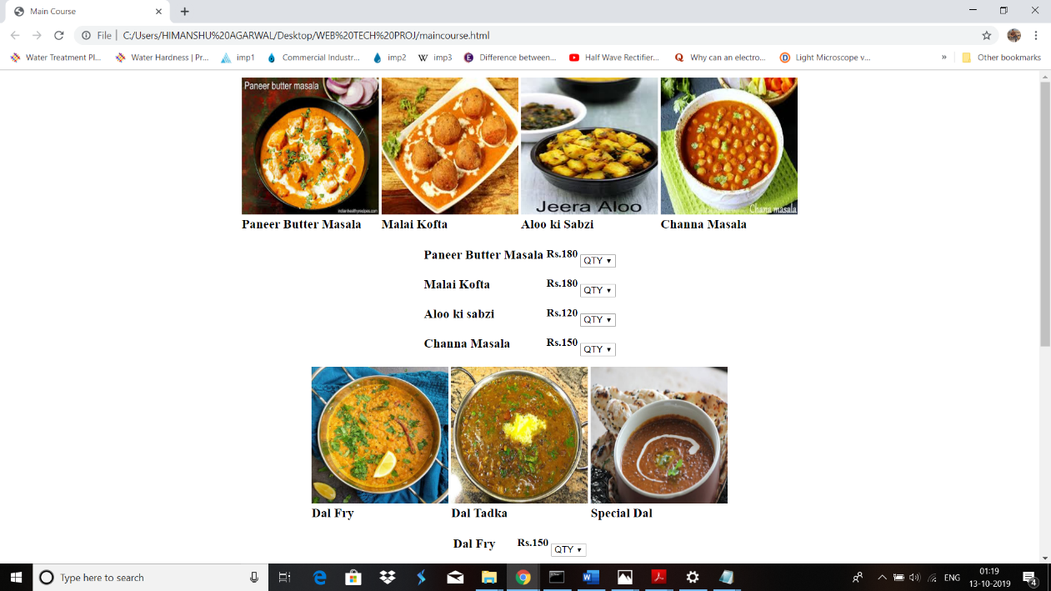

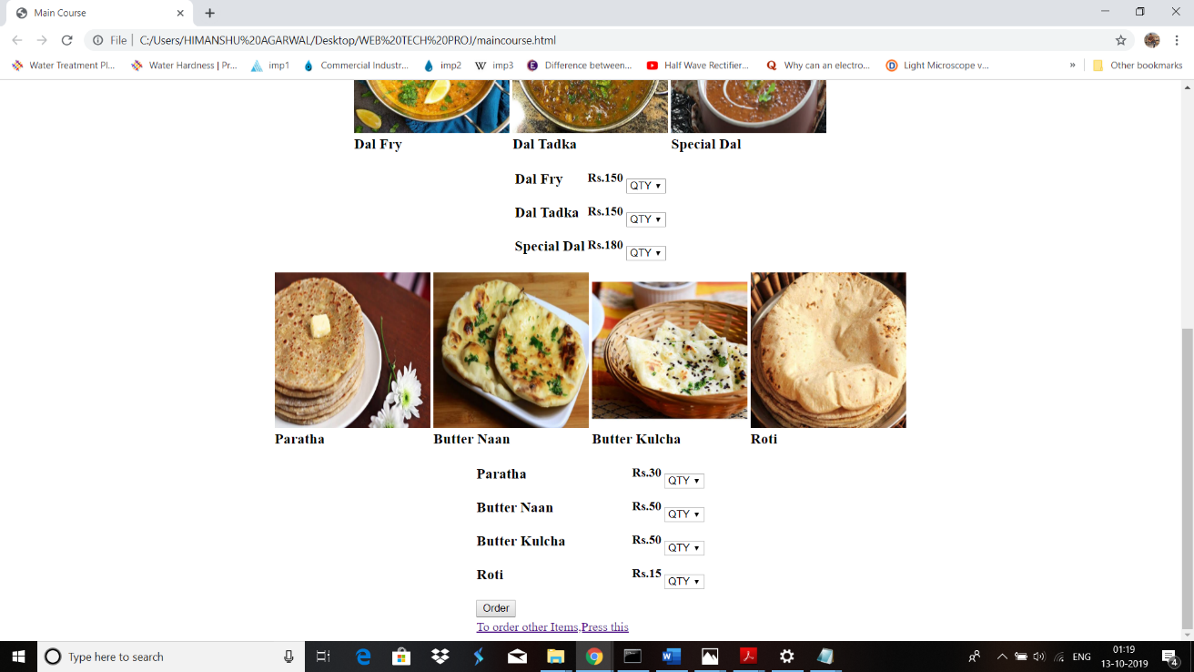

**Dessert.html**

|  |  |
| --- | --- |
|  | <html> |
|  | <head> |
|  | <style> |
|  | img{ |
|  | height:200px; |
|  | width:200px; |
|  | } |
|  | </style> |
|  | <title>Dessert</title> |
|  | </head> |
|  |  |
|  | <body> |
|  |  |
|  | <table border=0 align="center"> |
|  | <tr> |
|  | <td><img src="d1.jpg" id="dessert1" ></td> |
|  | <td><img src="d2.jpg" id="dessert2" ></td> |
|  | <td><img src="d3.jpg" id="dessert3" ></td> |
|  | <td><img src="d4.jpg" id="dessert4" ></td> |
|  | </tr> |
|  | <tr> |
|  | <td><h3>Hot Brownie with<br> Ice Cream</h3></td> |
|  | <td><h3>Gulab Jamun</h3></td> |
|  | <td><h3>Chocolate MilkShake</h3></td> |
|  | <td><h3>Ice Cream</h3></td> |
|  | </table> |
|  |  |
|  | <table align="center" border=0> |
|  | <tr> |
|  | <td><h3>Hot Brownie with<br>Ice Cream</h3></td> |
|  | <td><h4>Rs.120<h4></td> |
|  | <td> |
|  | <select id="quantity1"> |
|  | <option>QTY</option> |
|  | <option>1</option> |
|  | <option>2</option> |
|  | <option>3</option> |
|  | <option>4</option> |
|  | <option>5</option> |
|  | </select> |
|  | </td> |
|  | </tr> |
|  | <tr> |
|  | <td><h3>Gulab Jamun</h3></td> |
|  | <td><h4>Rs.70<h4></td> |
|  | <td> |
|  | <select id="quantity2"> |
|  | <option>QTY</option> |
|  | <option>1</option> |
|  | <option>2</option> |
|  | <option>3</option> |
|  | <option>4</option> |
|  | <option>5</option> |
|  | </select> |
|  | </td> |
|  | </tr> |
|  | <tr> |
|  | <td><h3>Chocolate MilkShake</h3></td> |
|  | <td><h4>Rs.100<h4></td> |
|  | <td> |
|  | <select id="quantity3"> |
|  | <option>QTY</option> |
|  | <option>1</option> |
|  | <option>2</option> |
|  | <option>3</option> |
|  | <option>4</option> |
|  | <option>5</option> |
|  | </select> |
|  | </td> |
|  | </tr> |
|  | <tr> |
|  | <td><h3>IceCream</h3></td> |
|  | <td><h4>Rs.60<h4></td> |
|  | <td> |
|  | <select id="quantity4"> |
|  | <option>QTY</option> |
|  | <option>1</option> |
|  | <option>2</option> |
|  | <option>3</option> |
|  | <option>4</option> |
|  | <option>5</option> |
|  | </select> |
|  | </td> |
|  | </tr> |
|  | <tr> |
|  | <td><input type="submit" id="submit" value="Order"></td> |
|  | </tr> |
|  | <tr> |
|  | <td><a href="orderfood.html">To order other Items,Press this</a></td> |
|  | </tr> |
|  | </table> |
|  | </body> |
|  | </html> |

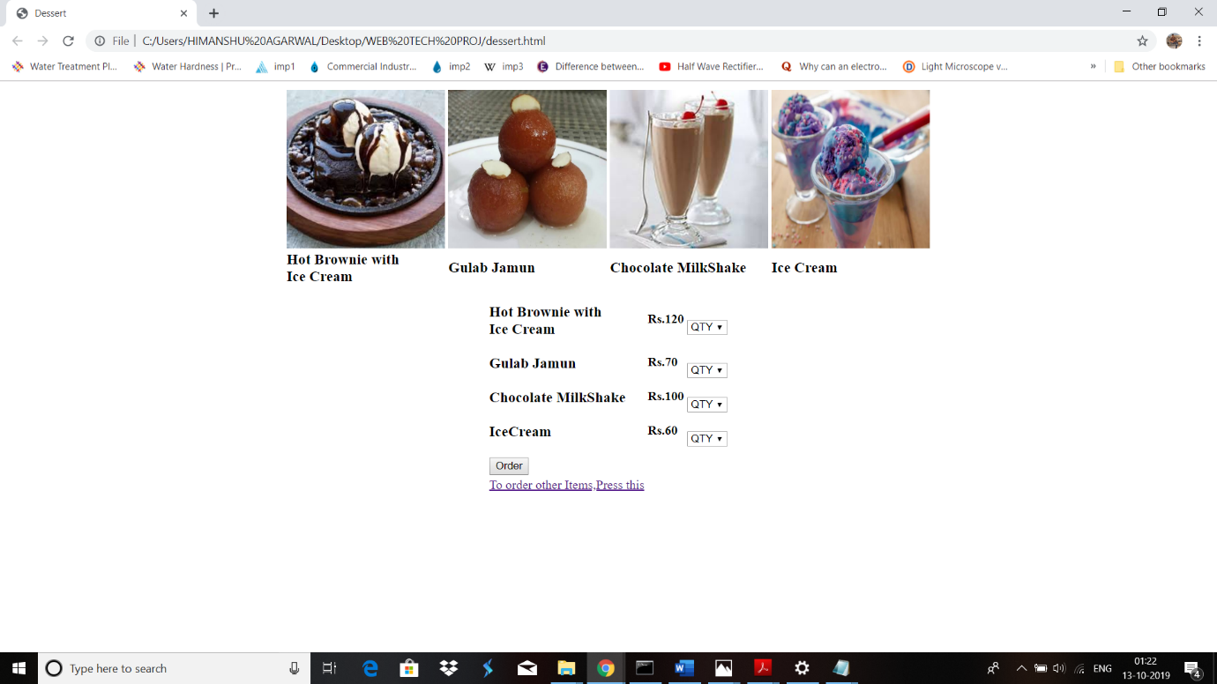

**CHECK ORDER**

**Orderstatus.html**

|  |  |
| --- | --- |
|  | <!DOCTYPE html> |
|  | <html> |
|  | <head> |
|  | <style type="text/css"> |
|  | body |
|  | { |
|  | background-color:white; |
|  | } |
|  | #panel, #flip { |
|  | padding: 5px; |
|  | font-size: 18px; |
|  | text-align: center; |
|  | background-color: #555; |
|  | color: white; |
|  | border: solid 1px #666; |
|  | border-radius: 3px; |
|  | } |
|  | #panel { |
|  | padding: 50px; |
|  | display: none; |
|  | } |
|  | </style> |
|  | <script src="<https://ajax.googleapis.com/ajax/libs/jquery/3.4.1/jquery.min.js>"></script> |
|  | <script> |
|  | $(document).ready(function(){ |
|  | $("#flip").click(function(){ |
|  | $("#panel").slideDown(5000); |
|  | }); |
|  | }); |
|  | </script> |
|  | </head> |
|  | <body> |
|  | <table align="right" border="1" bgcolor="red"> |
|  | <tr> |
|  | <td><a href="orderfood.html"><b>Order Food</b></a></td> |
|  | <td><a href="orderstatus.html"><b>Check Order Status</b></a></td> |
|  | <td><a href="editprofile.html" target="_self"><b>Edit Profile</b></a></td> |
|  | </tr> |
|  | </table> |
|  | <div id="flip">Click to see update on your Food Ordered.</div> |
|  | <div id="panel">THE FOOD ORDERED WILL BE SERVED IN 30MINS.</div> |
|  | </body> |
|  | </html> |

